**Week 1 – Git & Github**

**Exercises:**

1. **Repository Creation**
2. **Clone bootcamp2022 repo(use git clone https://github.com/cserl-iitb/bootcamp2022.git command).**

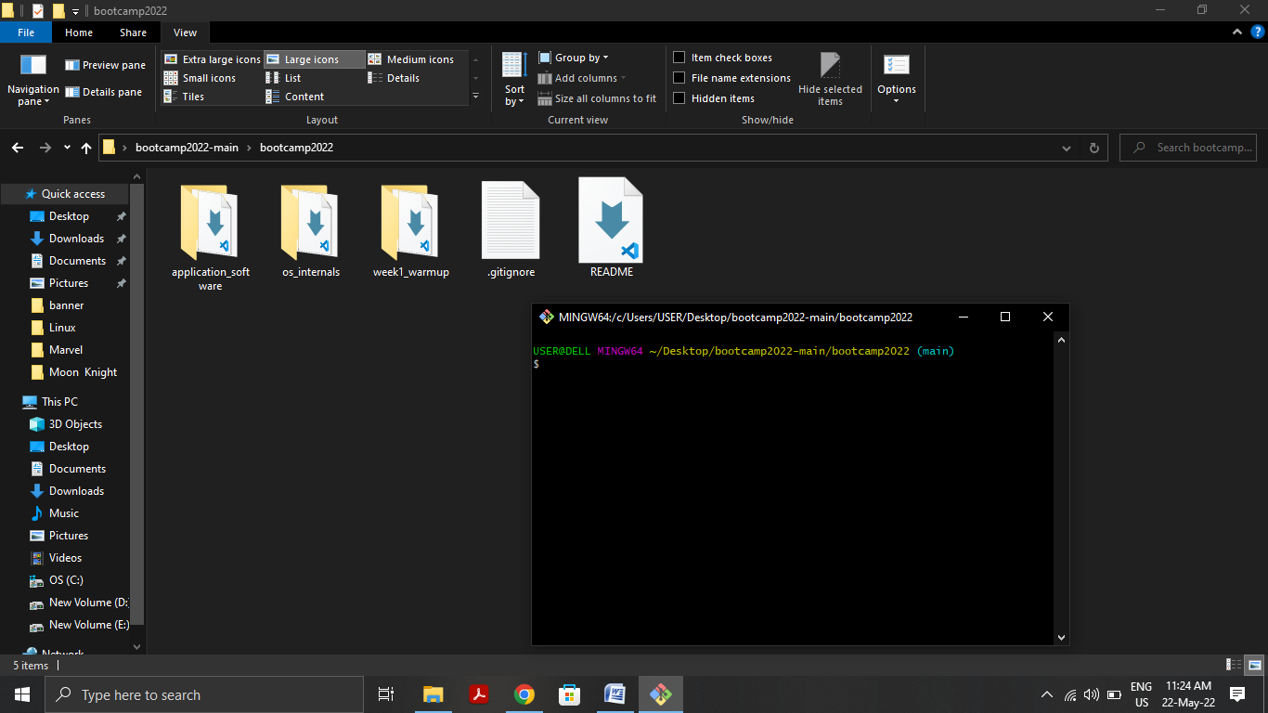

1. **Create a new private repository named <Bootcamp_2022_my_submission> (or any other similar name) from your account.**

**Clone it on your local machine (use git clone <url> command).**

**Make a new folder named <Week1_solutions> inside it.**

**Copy files from bootcamp2022/week1_warmup directory to the <Week1_solutions> directory.**

**Do add, commit and push on your repository.**

**Push your solutions onto your repo periodically.**

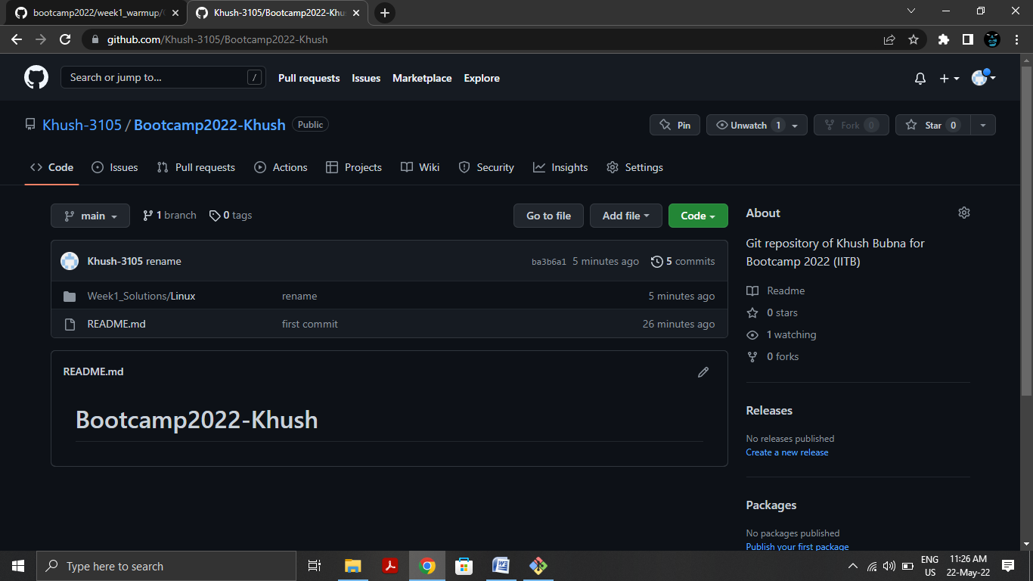

1. **Do you want to fix a bug?**
2. **Fork this repository. This will create a copy of repository on your account.**

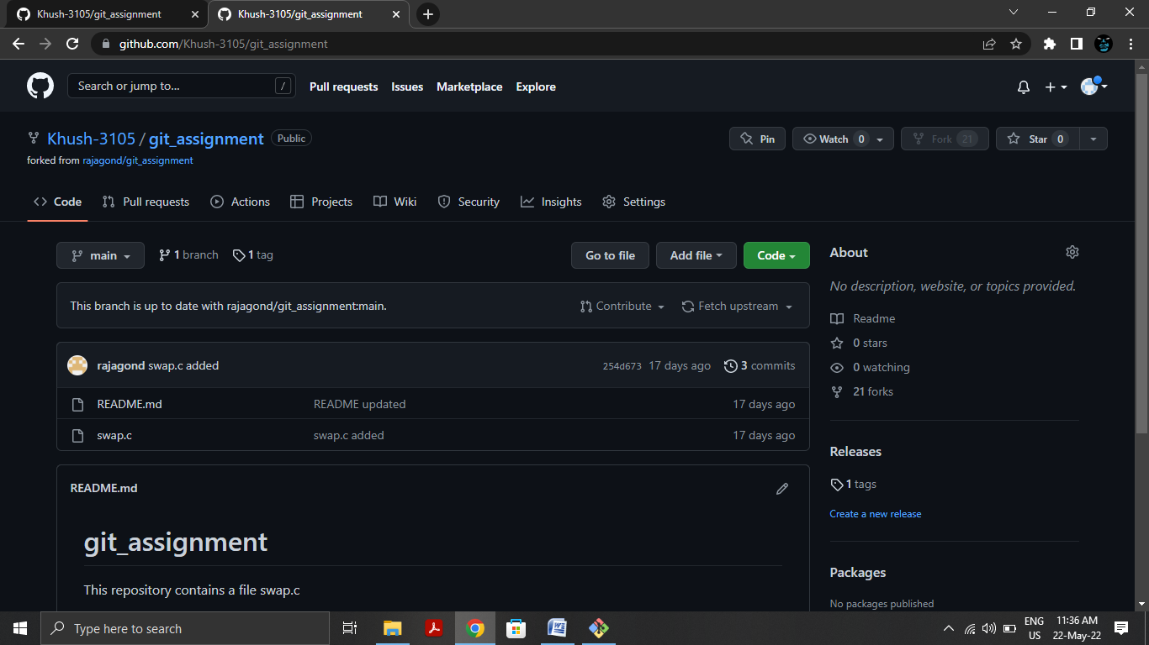

1. **Clone the repository you just created using fork from your github account onto your local machine (use git clone <fork_url> command).**

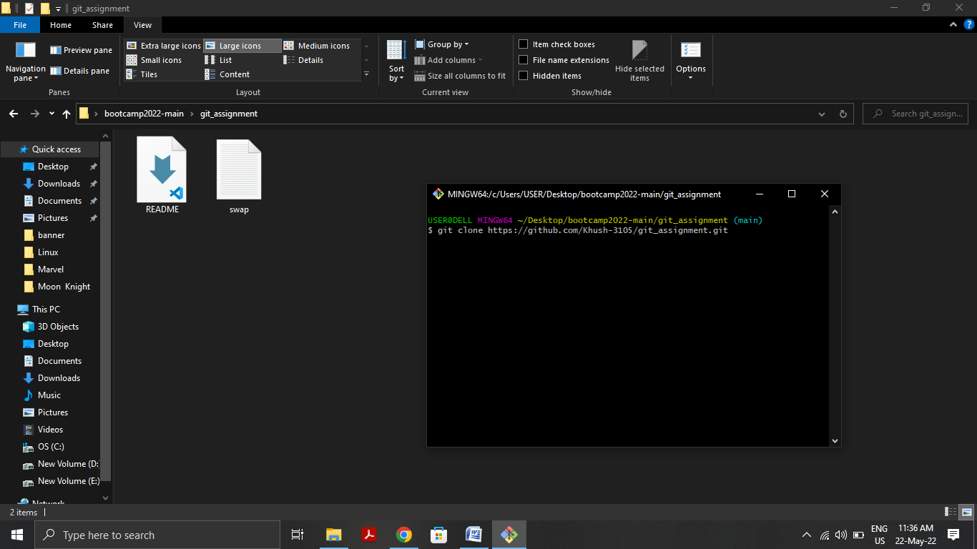

1. **cd git_assignment**

**git checkout -b <new_branch> ( -b flag tells Git to run git branch <new_branch> before running git checkout <new_branch>.)**

**Fix bug (test it) and add gitignore file to tells git to ignore a.out file.**

**git add .**

**git commit -m "bug fixed"**

**git push -u origin <new_branch>**

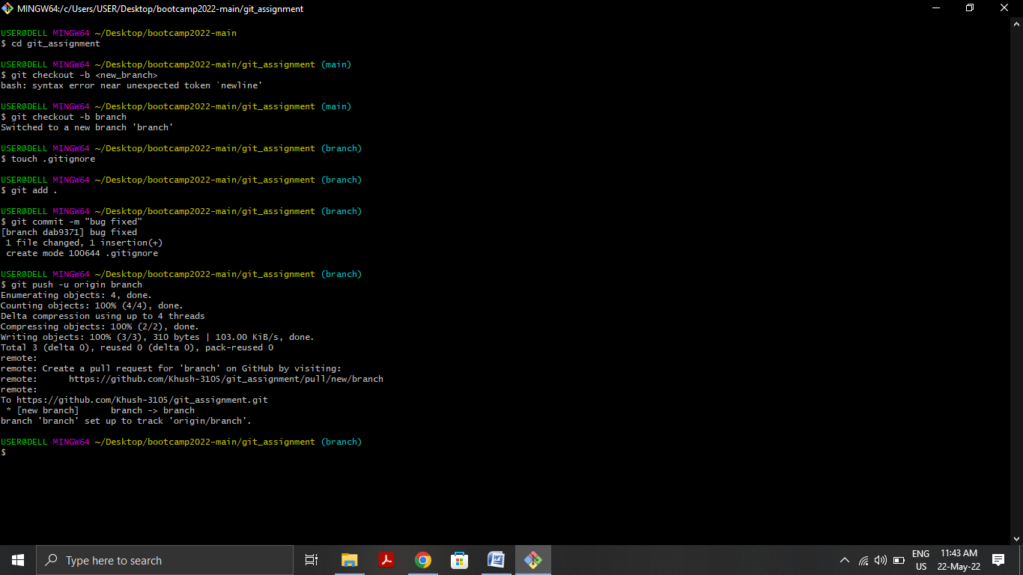

1. **Now merge the <new_branch> into main by following below four commands:**

**git checkout main**

**git pull origin main**

**git merge <new_branch>**

**git push -u origin main**

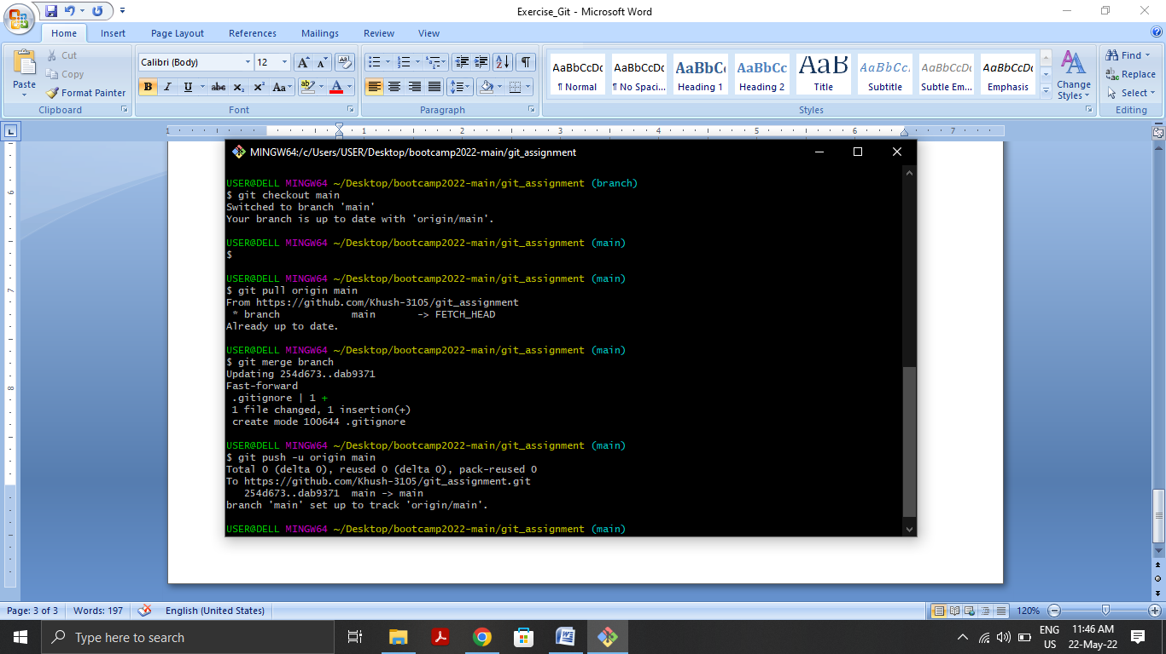

1. **git tag (This command will print submission on terminal. Lookup online to know more about what git tag does.) Note that it prints submission because the submission tag was already created in the original repository.**

**Now, delete the submission tag from both local and remote repo.**

**git tag -d submission(delete local tags)**

**git push origin :refs/tags/submission(push changes to remote repo)**

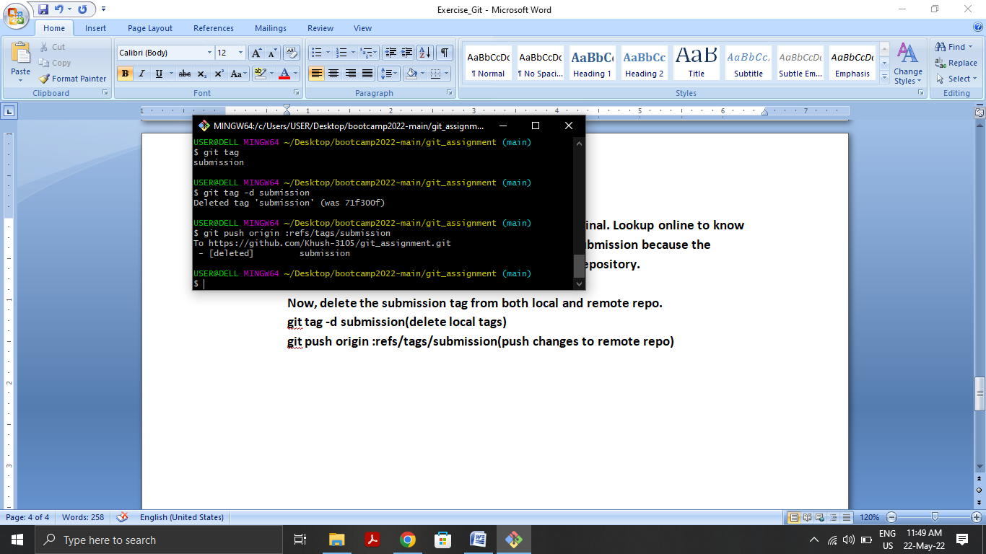

1. **Create a new tag final_submission and push it on your repository.**

